The Model ‘F’ Signal Laboratory User’s Guide

1

Introduction

This User’s Guide provides an overview of the Model ‘F’ signaling and wireless energy transfer development environment to get you started working with the product right away. It also tells you where to look for details about the tools and features available in the device and the array of configurations available.

Chapter 2, “A tour of the apparatus” describes the main tools on the WebPort desktop, or signaling desktop environment (SDE). Chapter 3, “Transmitting with ‘F’” explains the tools used to create a managed transmission and some of the physics behind it. Chapter 4, “Creating a managed transmission—a tutorial” takes you step by step through a process to create all the components for your environment complete with a webshop ready for activation the moment you complete the tutorial. Chapter 5, “The signal laboratory” describes how you can analyze and process the data for your development needs.

What is the wireless energy transport device?

The Model ‘F’ is a modular, time-domain independent wireless energy and signaling device for rapid and efficient transmission and distribution of current to a multitude of objects.

Using WebPort, you can create highly efficient applications and program templates with robust data-connectivity layers for Microsoft Internet Information Services (IIS) and Microsoft SQL with a minimum of manual coding. WebPort also provides a simple cross-platform solution when used in conjunction with Cylix, NovoPort’s RAID tool for Macintosh OSX and Xylix, a RAID tool for Linux using the Mono Framework. WebPort provides all the tools you need to develop, test, and deploy applications, including a large library of reusable components with the ability to be expanded as you need them, a suite of design tools for your innovative ideas, webform templates, and programming wizards.

Finding Information

You can find information on the Model ‘F’ in the following ways, described in this chapter:

● Online Help
● Printed documentation
● Cartheur developer support services and Web site

For information about new features in this release, refer to What’s New in the online Help Contents and to the www.cartheur.com Web site.

Online Help

The online Help system provides detailed information about user interface features, object and control implementation, programming tasks, and the components in the Visual Component Library Reference (VCL). It includes all the material in the WebPort Experimentor’s Guide and a host of Help files for other features bundled with WebPort such as the Module Developer’s Package (MDP).

To view the table of contents, choose Help | WebPort Help and Help | WebPort Tools, and click the Contents tab. To look up VCL or MDP objects or any other topic, click the Index or Find tab and type your request.

Printed documentation

This Quick Start is an introduction to WebPort. To order additional printed documentation, such as the Module Developer’s Guide, refer to the latest offerings at shop.novoport.net.

Developer support services and Web site

NovoPort also offers a variety of support options to meet the needs of its diverse developer community. To find out about support, refer to http://www.novoport.net/developer/.

From the Web site, you can access many newsgroups where WebPort developers exchange information, tips, and techniques. The site also includes a list of books about WebPort, additional WebPort technical documents, and Frequently Asked Questions (FAQs).

Typographic conventions

This manual uses the typefaces described below to indicate special text.

Table 1.1 Typographic conventions
Typeface | Meaning
Monospace type | Monospaced type represents text as it appears on screen or in code. It also represents anything you must type.
Boldface | Boldfaced words in text or code listings represent reserved words or compiler options.
Italics | Italicized words in text represent WebPort identifiers, such as variable or type names. Italics are also used to emphasize certain words, such as new terms.
Keycaps | This typeface indicates a key on your keyboard. For example, “Press Esc to exit a menu”.

2

A tour of the apparatus

This chapter explains how to start WebPort and gives you a quick tour of the main parts and tools of the desktop, or integrated desktop environment (IDE).

Starting WebPort

You can start WebPort in the following ways based on your installation. The most common, using IIS on a local machine:

● Transmitter (Tx) pad,
● Receiver (Rx) pad,
● coupled resonant objects—elevated aerials.

The IDE

When you first start WebPort, you’ll see the login screen:

Figure 2.1 The Login Screen
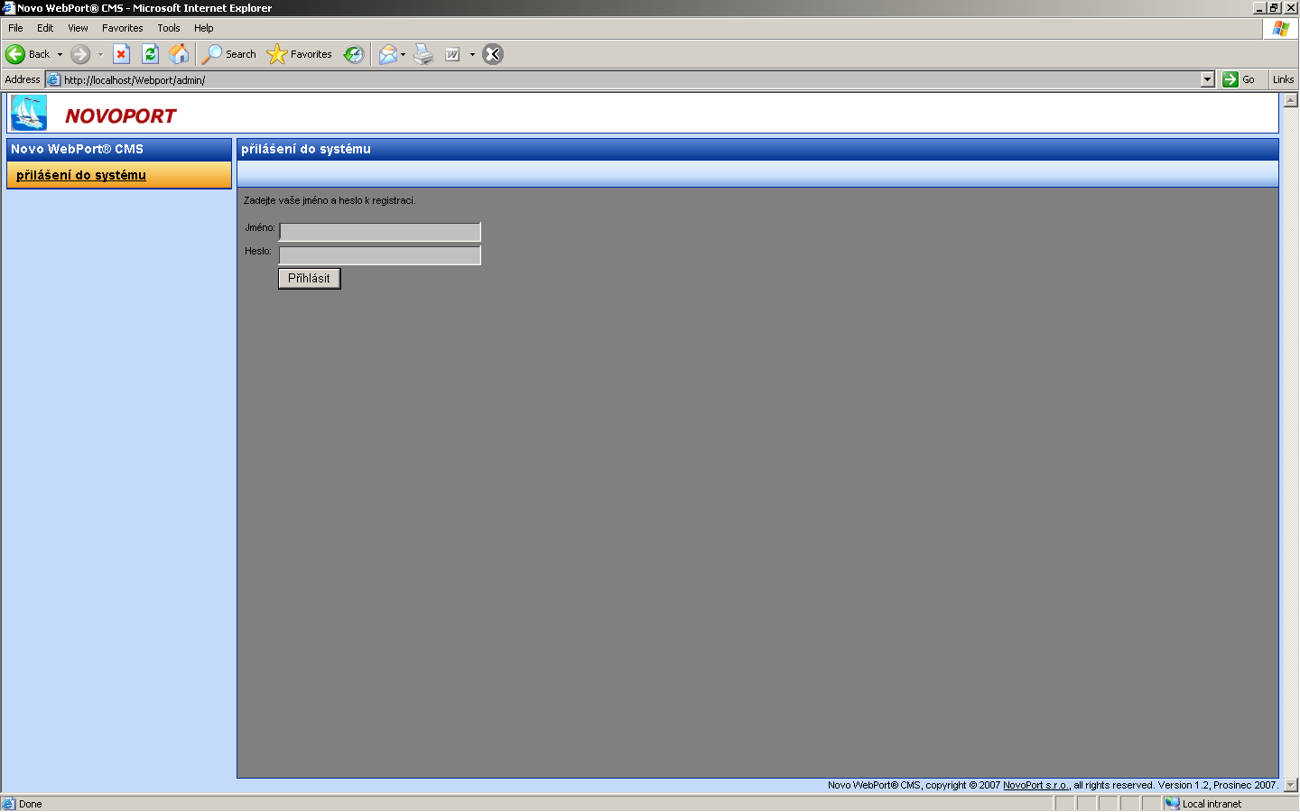

Input the username and password provided to you when you purchased the product and after clicking “Login”, you will see the main desktop.

Figure 2.2 The Main Desktop
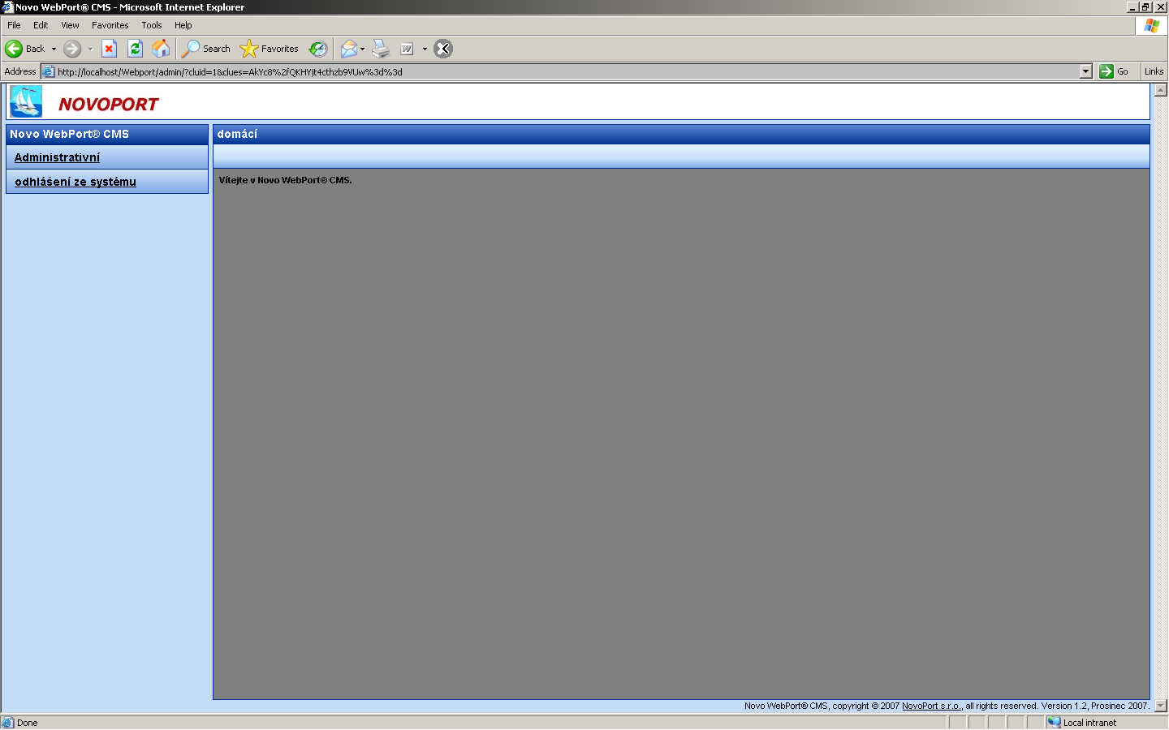

Continue…

3

The signal laboratory

This chapter explains the contents of the signal laboratory, details its components, and demonstrates a practice of “best usage” to allow ideal results for data processing and management for personal or public demonstrational requirements.

Setting up the signal laboratory

The signal laboratory provides a great deal of flexibility and power to allow ease of usage and to maximize your results. From the tutorial in Chapter 4, you have a sense of how the environment is designed to operate and how it can be customized for your own purposes.

Getting to know your modules

The Model ‘F’ has been designed to be a modular, time-domain independent wireless energy and signaling device for rapid and efficient transmission and distribution of current to a multitude of objects. With this feature in mind, the Model ‘F’ contains (six) modules that can be arranged in such a way to provide a different set of behaviors available to the engineer. The modules are organized by the mutual action between their components where each of the individual states set the other(s) into motion while at a distance from each other. For such a description, it is optimal the modules are grouped by those components designed to interact with each other most strongly, then more weakly. For example, consider a diagram of the components are their relation in the signal laboratory, shown in Figure 1.

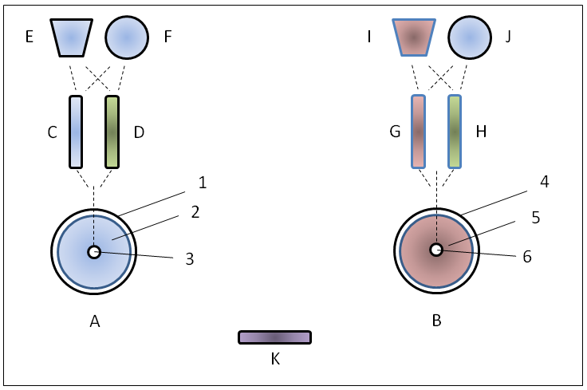
Figure 1: Signal laboratory modules.

The signal laboratory modules, shown in Figure 1, are put together in various configurations to allow the experimenter to send electrical currents via magnetic resonance at a sensible distance. The sensibility is determined by the intentions of the particular experiment. For example, by using components A and B and applying a sinusoidal signal, of a frequency given the parameters of both A and B, will allow the signal to be transmitted using a zero-order magnetic field from A to B, set at a distance from each other. The distance, thought not expressly quantified in the equations (see §5), is dependent upon the size of A and B given the kit that has been purchased. In a kit where the radius of the secondary coil of A and B is 5 cm, the maximum extent should be no more than 2 meters.

The component A is the transmitter element while the component B is the receiver element. Both elements A and B are comprised similarly, that is, of the same wire type, wire thickness, wire length and winding style, however, the winding style of element B is opposite of A. This is the reason for the difference of color between the two elements. The same property applies to element I; given its similarity to E in wire type, wire thickness, wire length and winding style, however, the winding style of element I is opposite of E. Elements G and H, while having the same wire type and wire thickness of elements C and D, have a different wire length and winding style. Element K, while sharing the same wire type, wire thickness and wire length of C, has a different winding style. Elements D and H are blank, that is, absent of any wire or conductor surfaces.

4

Transmitting with ‘F’

This chapter explains how to start transmitting and gives you a quick tour of the main components and tools of the apparatus, or signaling development environment (SDE). This chapter will also detail some of the physics and some data display. For this, a computational environment is required such as Matlab or Scilab. The former requires a purchased licence while the latter is freely available for use. Both are reasonably the same—that is, use a similar C-compiler—and interface in approximately the same manner.

Setting up a transmission environment using test equipment

If using test equipment to provide input to the transmission environment, there is an optimal arrangement to do this. In order to properly set up such an ideal transmission environment of this type, you will need to make yourself aware of the particular components and ancillary equipment required. The most convenient method is to collect what is required. Familiarize yourself with the portable kit, it contains all that is needed.

- A radio-frequency (RF) Colpitts oscillator, Hewlett-Packard 8651A, having a useful range for stimulus signaling in a frequency of the range 10MHz to 70MHz and amplitude of the range 50mV to 3 Volts,
- Optional: Hewlett-Packard 8654B 10MHz to 520MHz with an amplitude range of -120dBm to +10dBm, internal and externally-driven AM and calibrated FM,
- A spectrum analyzer of an appropriate signal range. Recommended: Hewlett-Packard 8590A 1.75GHz, GPIB communication interface,
- Three (3) lengths of 1 meter BNC 50Ω cable,
- One (1) T-splitter BNC,
- Two (2) lengths of 5 meter BNC 50Ω cable,
- Words.
- Three (3) power cables suitable for European (240V), UK (240V), or US (110V),
- Two (2) adapters for European and UK (240V) power,
- Words.

Setting up a transmission environment using an embedded oscillator

If using an embedded oscillator and amplifier package to provide input to the transmission environment, there is an adjusted arrangement to do this. When examining the transmission element A, you will notice the primary coil 1 has three wires, as opposed to two in the version designed for test equipment. In order to properly set up such an ideal transmission environment of this type, you will need to make yourself aware of the particular components and ancillary equipment required.

Words.

5

Equations of the signal laboratory

This chapter describes the mathematical equation for the components from §3 used in the signal laboratory.

Maxwell’s equations in the signal laboratory

Well-understood in electromagnetism are Maxwell’s equations which are a mathematization of the experiments of Faraday. Couched in the days of early electromagnetism, these equations to this day serve as a means to represent and calculate properties of physical systems. There is an essence for the experimenter to glean which is not widely known. The equations used to describe the signal laboratory and the mathematical framework to derive properties and transmission variables are taken from J.C. Maxwell’s A dynamical theory of the electromagnetic field. If the experimenter is interested in acquiring this paper, it is in the public domain at the time of writing of this document and can be obtained also by contacting your local sales representative.

The ideal “magnetic loop” which consists the primary coil of A, is determined in the laboratory by the following formulation,

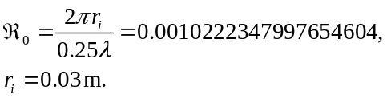

It is advantageous to choose the resonance frequency, as a function of the coil, such that the ratio of the loop radius to wavelength falls as near to a ratio 0.1 on scales of ten, e.g., 0.01, 0.001, etc. In this fashion, the emission of (electromagnetic) photons by the loop approaches a maximum value.

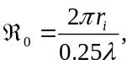 (5.2)
Words.

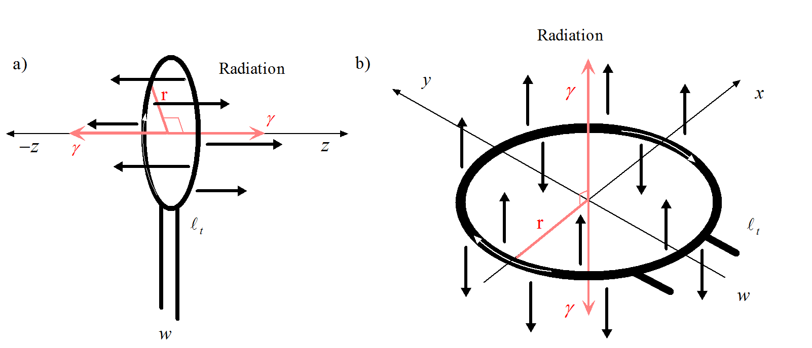
Figure 2: Emission of photons by the coil.

Words.

6

Creating a fully managed transmission—a tutorial

This chapter explains the use of the signal laboratory combined with the server software to create a fully managed transmission.

Steps to create a fully managed transmission

Words.

